

Access Statement for
The Worthing Lido Family Entertainment Centre
December 2015
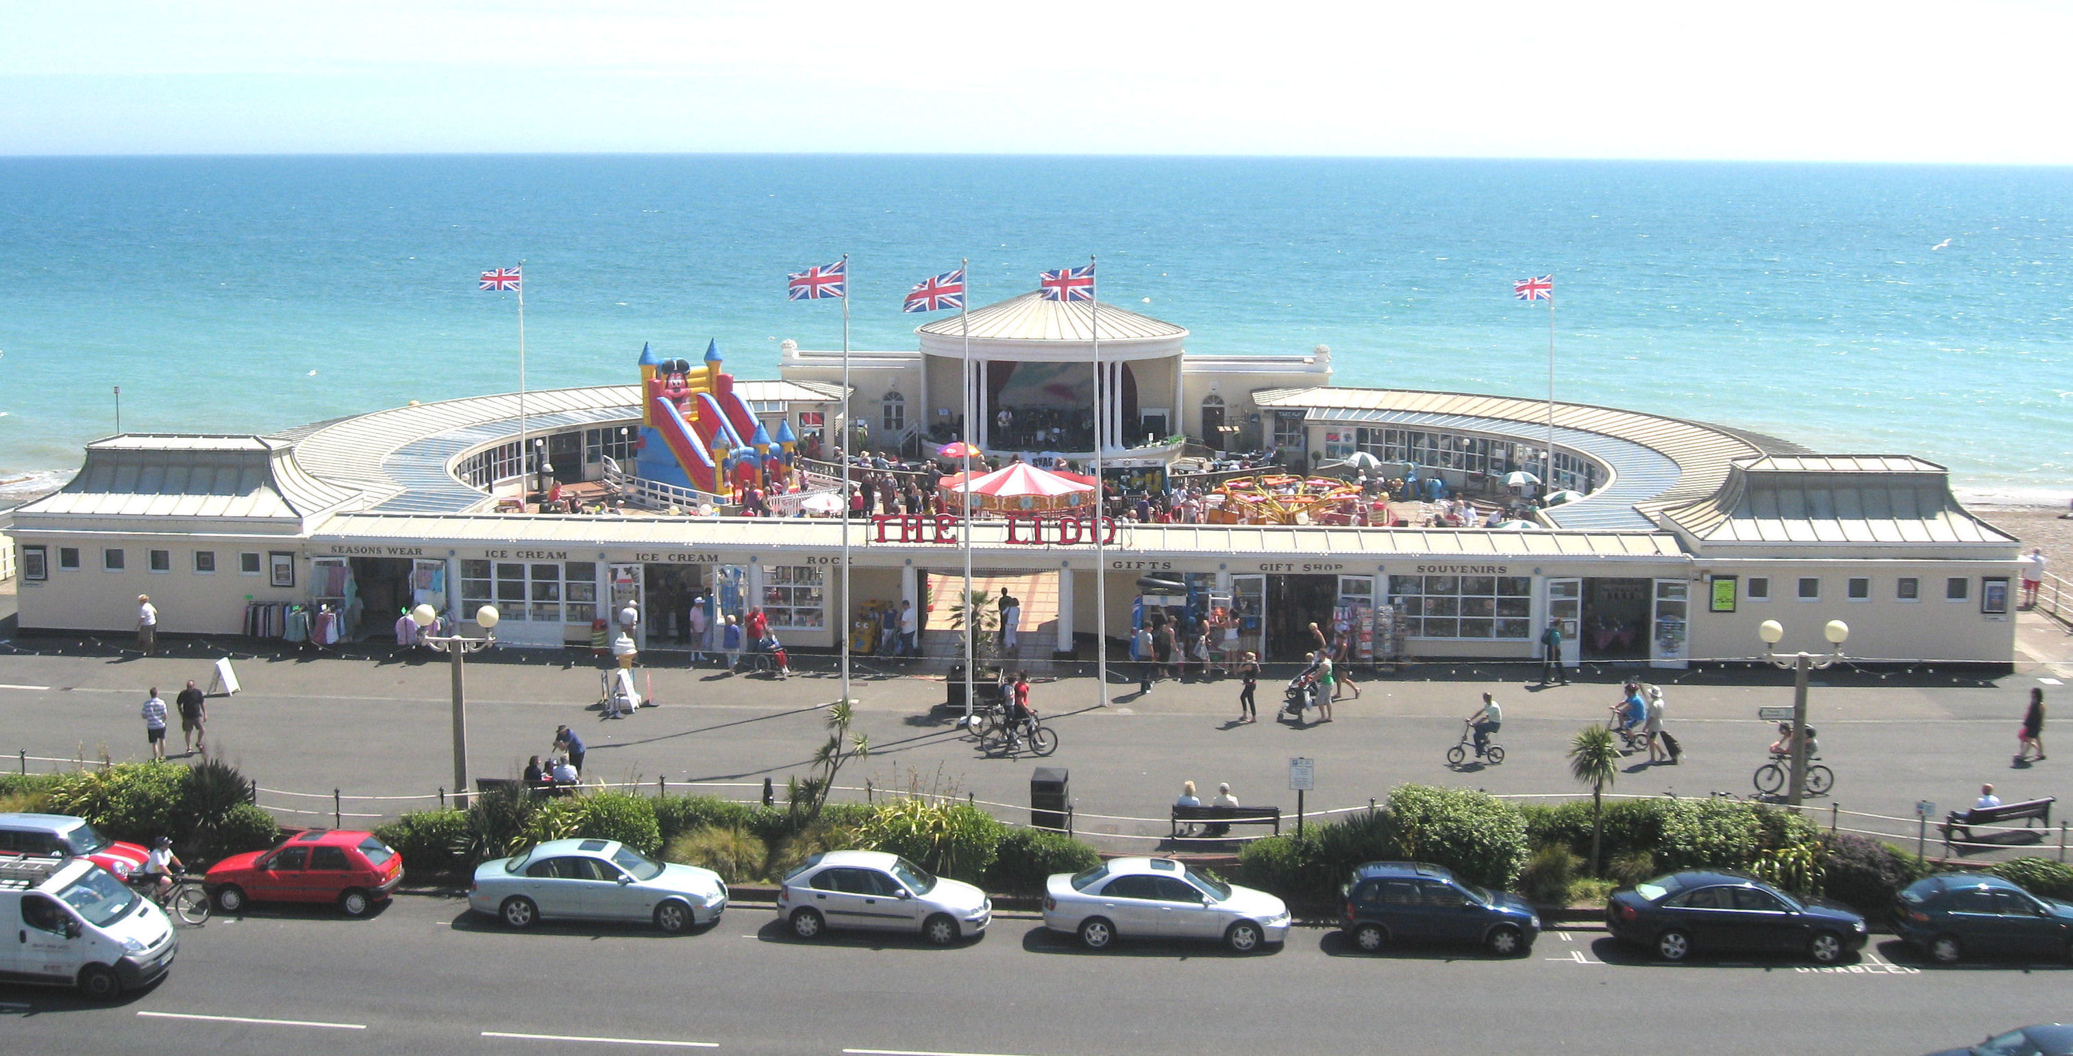

The Lido, Marine Parade, Worthing, West Sussex, BN11 3PX
Tel: 01273 706 773 Fax: 01903 215 491
E-Mail: admin@theworthinglido.co.uk
Website: www.theworthinglido.co.uk
This access statement does not contain personal opinions as to our suitability for those with access needs, but aims to accurately describe the facilities and services that we offer all our guests/visitors.

Table of Contents

Table of Contents 2
Introduction 3
Pre-Arrival 4
Car Parking and Arrival 5
Main Entrance, Reception and Ticketing Area 6
Attraction (displays, exhibits, rides etc.) 7
Public Toilets 8
Catering 9
Shop(s) 10
Grounds and Gardens 11
Additional Information 12
Contact Information 13

Introduction
Situated in a prime spot on Worthing's promenade, The Worthing Lido Family Entertainment Centre is an attraction catering for all ages. It offers a variety of children’s rides, a large cafe with superb sea views serving a comprehensive range of snacks, light lunches and drinks. The Lido also contains a small souvenir and gift shop, an ice cream and rock shop as well as a traditional seaside amusement arcade.
The Worthing Lido is on one level with a raised decking area outside around the iconic Grade 2 Listed bandstand. The entire site has either level access or ramps, making the whole site accessible for all.
Staff are on hand throughout the complex and will be happy to help should you require any assistance during your visit.
We look forward to welcoming you. If you have any queries or require any assistance, please phone 01273 706 773 or email admin@theworthinglido.co.uk.

Pre-Arrival
- For full details and maps of how to reach us please see the 'Plan your visit' section of our website. Alternatively, you can plan your journey by car or public transport using a journey planning website; simply enter your postcode and ours, which is BN11 3PX to get directions.
- The nearest railway station is Worthing, which is situated just under 1 mile away to the North (a 15-20 minute walk). Frequent and accessible bus services connect the station to the town center which is just a few minutes’ walk from us. Alternatively, there is a taxi rank located right outside the station.
- The nearest bus stop is right outside and is serviced by a number of local routes using accessible busses.
- The promenade is above road level and is accessed via steps and ramps conveniently located at regular intervals. The closest ramp is right outside to the West of us adjacent to the accessible on street parking and pelican crossing leading to the multi-story car park.

Car Parking and Arrival
- There is no on-site parking however, outside there is on street pay and display parking with 2 clearly marked Blue Badge parking spaces which are located adjacent to the ramp accessing the promenade. Pay and display parking charges apply Monday - Saturday (Except Bank Holidays) and is charged at 20p per 10 minutes with a maximum stay of 2 hours.
- Additional parking can be found in the 450 space 10 floor multi-story car park opposite which is run by the council and offers parking from just £1 per hour. This car park has full lift access between 8AM - 6PM and also contains 6 accessible parking spaces.

Main Entrance, Reception and Ticketing Area
- The main entrance to the site is via a 4m wide gateway with overhead lighting and a block paving floor situated at the front of the building under the large neon sign. This takes you directly to the main outside area of the attraction where the Children's Rides, Bandstand and Seating are situated.
- The shops are accessed directly from outside the complex via doors that are a minimum of 0.95m wide. There are no steps to the shops, however please be advised that there is a slight raised lip in the doorway.
- The cafe / restaurant has a number of access points. There is a ramp situated inside the main complex which is 1.23m wide leading to door that is a minimum of 0.95m wide. An addition ramp is located outside the complex by the outdoor seating area. This leads to a doorway which is 1.42m wide.
- The amusement arcade has a single ramp which provides step free access, this ramp is 1.23m in width and leads to a door which is a minimum of 0.95m wide.
- We welcome guide dogs in all parts of the complex.

Attraction (displays, exhibits, rides etc.)
- All areas of the complex are clearly sign posted with the majority of signs being in red and black text on a white background.
- In the outdoor part of the complex we have several speakers playing background music at a low volume.
- There is plenty of seating provided at regular intervals around the complex in the form of tables and chairs, picnic benches, standard benches and stools.
- Doors have a minimum of 0.95m openings throughout the complex and are all manual doors however, if you require assistance please ask any member of staff who will be happy to help.
- Flooring throughout the complex is flat with the main outdoor area finished with block paving and a large wooden decking area. The amusement arcade is fully carpeted throughout as is the gift shop. The remaining shops have tiled floors and the cafe / restaurant is a mix of tiled and vinyl flooring with the main walk way carpeted.
- The complex is well lit with bright LED spotlighting throughout; Please be advised that due to the nature of the amusement arcade there are some flashing lights on machines.

Public Toilets
- Public toilets are located inside the cafe area of the complex and are well lit with fluorescent spot lights throughout.
- The toilets have a non-slip tiled flooring and are split into separate Ladies and Gents toilets.
- The ladies toilet consists of three cubicles which have 90cm wide doorways that open outwards. The toilet heights are 40cm floor to seat.
- There are also two large sinks with twist taps with a large mirror in front and an electric hand dryer provided.
- Baby changing facilities are available within the ladies toilet and have a 90cm door leading to them.
- The gents toilets only has three urinals and a large sink with twist taps due to lack of space. An electric hand drier is also provided.
- Further ladies and gents toilets are available on the outside of the complex at either end of the building. These toilets are run by Worthing Borough Council and managed by Wettons Cleaning Services.
- An accessible toilet with RADAR key is also available on the outside of the complex, also run by Worthing Borough Council and managed by Wettons Cleaning Services. This toilet has grab rails available and also a red alarm cord which is connected to the Worthing Borough Council Foreshore office adjacent to The Lido.
- A RADAR key is available on request from The Lido Cafe or from the Worthing Borough Council Foreshore Office.

Catering
- The restaurant / cafe area is in a slightly raised area with three 12cm steps to access. The main doorway has a handrail in the center of the steps and leads to a 0.95m wide doorway. There is a ramp at the northern end which is 1.23m wide and leads to a 0.95m door.
- Once inside the cafe is level throughout and there is ample room for wheelchairs and buggies to maneuver.
- The whole area is well lit with ceiling spotlights and the flooring is finished with a mix of non-slip tiles and vinyl as well as carpeted areas.
- Wooden tables and high backed chairs are well spaced apart, with a clear height from the floor of 70cm. There is space to accommodate wheelchair users at tables and also highchairs available if required.
- Service is available either at the large counter or at the table with menus displayed on large blackboards above the counter. A printed copy of the menu as well as a large font version are available on request from any member of staff in the cafe.
- All staff are up to date to with all changes made to the menu and are able to assist with details of any allergens. An alternative allergen identification table is available on request.

Shop(s)
- The Lido comprises of a large gift shop with a range of souvenirs and mementos at the front of the complex. This can be accessed directly from the promenade next to the main entrance gateway. There is a slight incline to the gift shop, however once inside the shop is level throughout. The door entrance is a minimum of 0.95m in width and these doors are normally kept open when in business. Inside the gift shop there are several display racks and fixtures in the middle of the shop. There is only enough room to maneuver a small wheelchair around the shop surface, however if you require any assistance the staff team will be willing to help.
- The Lido complex also has an ice cream and rock shop which is on the other side of the main entrance. In similarity to the gift shop this can be accessed in the same way from off the promenade. The flooring is tiled and has plenty of room to maneuver a wheelchair or similar. The shelving in this shop of a low height making it accessible to purchase goods, and with a low side counter where things can easily be purchased if required by a wheelchair user.
- Situated next to the ice cream and rock shop is a clothes shop. The clothing rails have two heights, one being low and one higher up, however someone is always on hand to help. This shop also has a fitting room if you require to try on clothing items. The flooring is tiled and access to the shop is ramped with a 0.95m width door as minimum.
- Further down on the front of the complex is another smaller shop once again easily accessible from the promenade.

Grounds and Gardens
- When entering the complex, you will be greeted by a large oval outdoor ground. Within this area guests have access to a variety of seating and benches on two levels of floor within intervals. The first is at ground level and the other has a ramp leading access to the bandstand where music is sometimes on show.
- The ground and lower outdoor complex is filled with even block paving for accessible use. The second ground level has wooden decking and can sometimes become wet and slippery after it has been raining.

Additional Information
- We welcome trained assistance dogs throughout the complex. A water bowl is available from the Cafe or Ice Cream shop on request.
- Persons with disabilities are able to use the majority of our children's rides and staff will be more than happy to help parents to assist children on and off of the rides.
- Qualified first aiders are available in the Worthing Borough Council Foreshore Office adjacent to The Lido where there is also a public Automatic Electronic Defibrillator available if required.

Contact Information
Address (Inc postcode): | The Lido, Marine Parade, WORTHING West Sussex BN11 3PX
Telephone: | 01273 706 773
Fax: | 01903 215 491
Email: | admin@theworthinglido.co.uk
Website: | www.theworthinglido.co.uk
Grid Reference: | TQ 14753 02304
Hours Of Operation: | Please see www.theworthinglido.co.uk/openingtimes
Local Equipment Hire: | Worthing Shopmobility  Address:  12-14 Liverpool Gardens  Worthing  BN11 1RY  Telephone: 01903 820980  Email: shopmobility@unicombox.co.uk  Website: www.shopmobilityuk.org Opening  Hours:  Mon - Fri 9.30am - 4.30pm  Sat 9.30am - 2.00pm  Worthing Shopmobility provides low cost hire of mobility scooters and wheelchairs to anyone with a mobility problem whether temporary or permanent.
Local Accessible Taxi: | To book a wheelchair accessible taxi service please contact Worthing Taxi Association on 01903 230302.
Local Public Transport: | Local bus routes 7, 7A 8, 8A & 9, 700 stop right outside us and services 1, 5, 10, 11, 16, 23, 85, 85A, 106, PULSE, N700 stop in the town centre.  The nearest mainline station is Worthing situated just under a mile away to the north.

